Total Internal Reflection
Daksh Khandelwal
March 28, 2026

Abstract
The critical angle and refractive index of a rhombic acrylic block are investigated to verify the principles of Snell’s Law. By systematically measuring the angles of refraction for various incident angles of light, the refractive relationship between acrylic and air is analyzed. The experimental data yields an estimated critical angle of $61.62°$. Discrepancies between this result and the theoretical expectations for acrylic are attributed to the lack of measurements approaching the critical boundary, resulting in extrapolation errors.

Introduction
The refractive index of a medium dictates the phase velocity of light through that medium relative to a vacuum. When light passes from a medium with a higher refractive index to one with a lower refractive index, the relationship between the incident angle $(θ_{1})$ and refracted angle $(θ_{2})$ is governed by Snell’s Law. Total internal reflection occurs when the incident angle exceeds a specific critical angle $(θ_{c})$, causing the light to refract at $90°$ and reflect entirely within the first medium. A complete derivation of the critical angle prediction is referenced and included in Appendix A.

Experiment
The apparatus consisted of a rhombic acrylic block, a directed light source, and a protractor ruled to $1°$ for angular measurements. The experiment was configured to direct the light source from inside the acrylic block into the surrounding air to observe refraction at the boundary.
The angle of incidence was systematically varied from $0°$ to $40°$ in $10°$ increments. For each incident angle, the corresponding refracted angle exiting into air was measured and recorded.

Figure 1a:  Experimental configuration at an incident angle of $0°$. The laser light source is aligned with the $0°$ mark on the circular protractor template. The beam passes through the rhombic acrylic prism and refracts at the air-acrylic boundary, emerging at a measured angle of $26°$. At this shallow angle of incidence, the majority of the light intensity is transmitted through the boundary as a refracted beam, with very little internal reflection. | 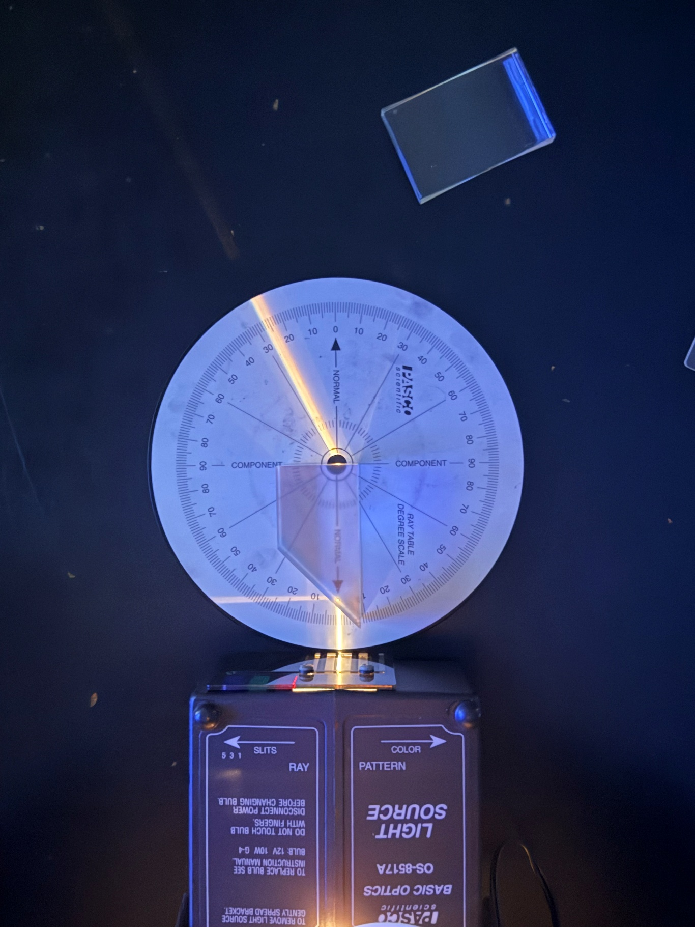
Figure 1b:  Experimental configuration at the maximum tested incident angle of $40°$. At this steeper angle, the refracted beam is bent significantly further, emerging at $83°$. Because this angle of refraction is closely approaching $90°$, the exiting light can be seen skimming just above the flat edge of the prism. Additionally, the internally reflected beam within the acrylic is visibly brighter compared to the $0°$ setup, demonstrating that the system is closely approaching the critical angle for total internal reflection. | 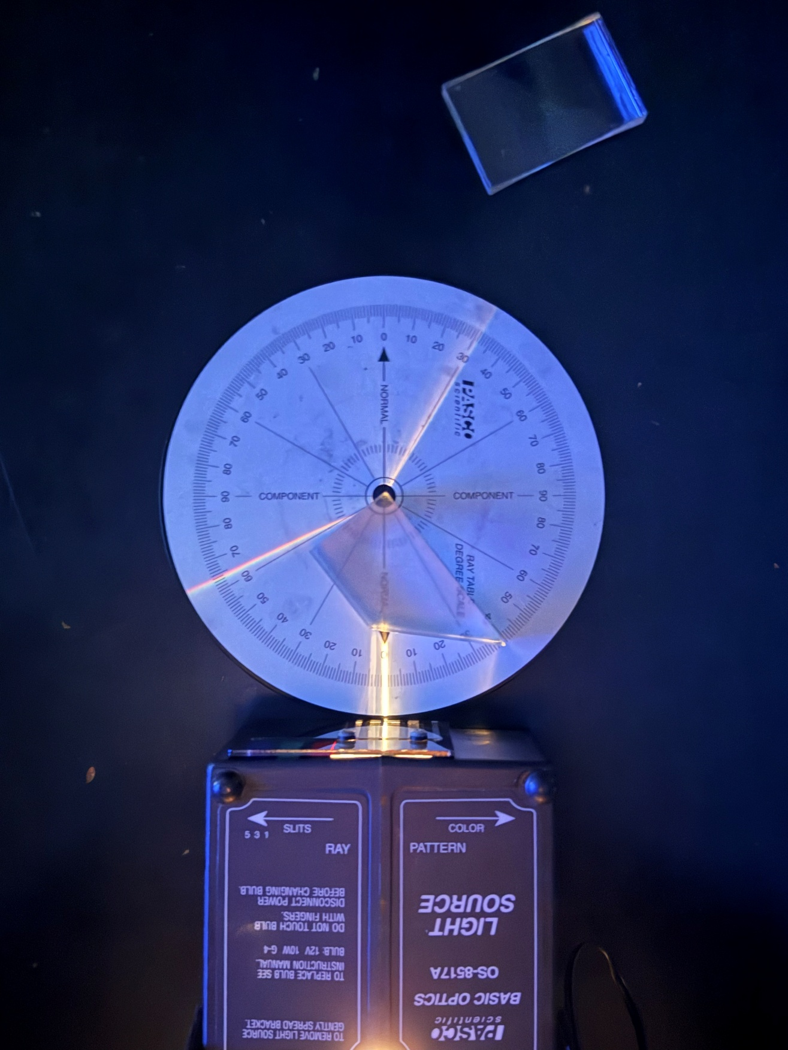

Data and Analysis
Table 1 displays the measured incident and refracted angles alongside calculated sine values.

Table 1: Measured angles and their sine values with uncertainty
Incident Angle $(θ_{1})$ | Refracted Angle $(θ_{2})$ | $$\sin{(θ_{1})}$$ | Uncertainty $s_{\sin{(θ_{1})}}$ | $$sin⁡(θ_{2})$$ | Uncertainty  $$s_{\sin\left(θ_{2}\right)}$$
$$0°$$ | $$26°$$ | $$0.0000$$ | $$0.0174$$ | 0.4384 | 0.0157
$$10°$$ | $$34°$$ | 0.1736 | 0.0172 | 0.5592 | 0.0145
$$20°$$ | $$47°$$ | 0.3420 | 0.0164 | 0.7314 | 0.0119
$$30°$$ | $$60°$$ | 0.5000 | 0.0151 | 0.8660 | 0.0087
$$40°$$ | $$83°$$ | 0.6428 | 0.0134 | 0.9925 | 0.0021

Individual angle measurements carried and absolute uncertainty of $±1°$. The uncertainties for the trigonometric function $sin⁡(θ)$ were mathematically manipulated using the half-difference method. Sample calculations for these uncertainties are referenced and included in Appendix B.

Figure 1 shows $\sin\left(θ_{1}\right)$ vs $\sin\left(θ_{2}\right)$, which demonstrates a highly linear relationship. A linear regression was applied to the dataset to extract the slope, which directly correlated to the refractive index of the acrylic block.
Figure 3: Scatter plot of $\sin\left(θ_{1}\right)$ versus $\sin\left(θ_{2}\right)$. Note that the linear fit utilizes data strictly $≤40°$.
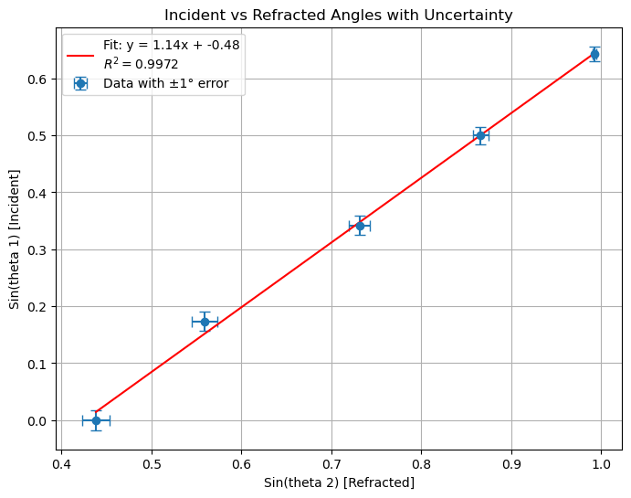

Results
Based on the linear analysis of the collected data, the experimental critical angle was calculated to be $61.62°$. The accepted theoretical refractive index for standard acrylic is approximately 1.49, corresponds to an accepted critical angle of roughly $42.15°$.

Discussion
The analysis successfully demonstrates the linear relationship predicted by Snell's Law. However, the calculated critical angle of $61.62°$. deviates significantly from the accepted theoretical value of $42.15°.$ While the data analysis quantified the propagated measurement uncertainties ($s_{\sin\left(θ\right)})$, these values were exceptionally small (ranging from 0.002 to 0.017). Consequently, the random measurement uncertainty of $±1°$ is negligible and cannot account for this large deviation.

Instead, this discrepancy is directly supported by the experimental data limitations: the highest measured incident angle was $40°$. Without data points closer to the actual critical boundary, the linear fit extrapolates the slope based solely on the flatter, early portion of the sine curve. Further investigation incorporating measurements between $40°$ and the expected critical angle is necessary to determine a precise and accurate refractive index.

Appendix A: Derivations
Derivation of Critical Angle:

Starting with Snell’s Law:
$$n_{1}\sin\left(θ_{1}\right)=n_{2}\sin\left(θ_{2}\right)$$
Defining the critical condition where the angle of refraction $(θ_{2})$ is exactly $90°$:
$$θ_{1}=θ_{c}$$
$$θ_{2}=90°$$
Substituting the values (where $\sin\left(90°\right)=1$ and $n_{2}≈1$ for air):
$$n_{1}\sin\left(θ_{c}\right)=1(1)$$
Solving for the relationship:
$$θ_{c}=\arcsin\left(\frac{1}{n_{1}}\right)$$

Appendix B: Sample Calculations
Half Difference Uncertainty Calculation for $\sin\left(30°\right)$:
$$s_{f}=\frac{1}{2}\left|\sin\left(30°+1°\right)-\sin\left(30°-1°\right)\right|$$
$$s_{f}=\frac{1}{2}\left|\sin\left(31°\right)-\sin\left(29°\right)\right|$$
$$s_{f}=\frac{1}{2}\left|0.5150-0.4848\right|=0.0151$$

